Caleb Javier
Adrianna Holden-Gouveia
Linux Administration
21 September 2025

Documentation: The Grep Family
The following documentation will demonstrate the use of the grep command, a tool used to filter and search for distinct text patterns in files.

Using a provided file, the following commands will demonstrate how to use different options and flags to filter the text found in that file and display it back to the user.

- Print all lines containing the string Lane
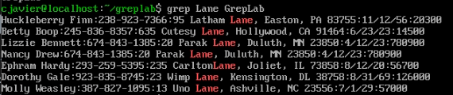
Command used: grep Lane GrepLab
Explanation: The command works by invoking the grep command, providing it an argument, and then a file to work with. The argument instructs the command to search the file for each line that contains that argument, and then prints it to the terminal for the user to read. Here, the command is given a single word (case-sensitive) and it prints out every line containing that instance. Notice the highlighted red characters match the input argument.

- Print all lines where the person’s first name starts with H
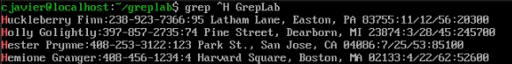
Command used: grep ^H GrepLab
Explanation: The new argument provided is ^H, which does two things: the caret signifies that the argument will be applied to the beginning of a line. The “H” instructs that it must be the first character found in that line. In this case, we know that the lines begin with names, so the only lines printed out are those beginning with “H”.

- Print all lines ending in three zeroes (000)
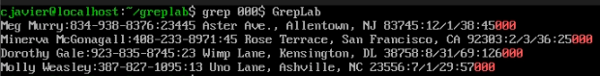
Command used: grep 000$ GrepLab
Explanation:This argument now follows a string with a $ symbol, which signifies the “anchor”, or end of a line in the file. The string provided (000) will now be scanned for whenever a file ends (before a newline) with that string.

- Print all lines that don’t contain 408
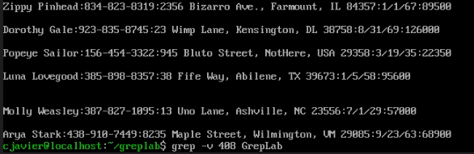
Command used: grep -v 408 GrepLab
Explanation: Options will alter how a command works. This command for example is very similar to the first, in that it searches for a single, simple string. However, using “-v”, which is the inverse match option, will display all lines that do not contain that string.

- Print all lines where birthdays are in the year 1935 (be careful of the date format! it’s MM/DD/YY)
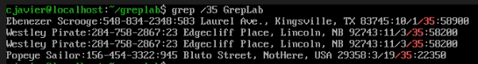
Command used: grep /35 GrepLab
Explanation: There is only one date in each line. Given the date format and the specified year, those born in 1935 must be in lines containing “/35”. We can search the file for that string, which provides all dates ending in 35.

- Print all lines where the phone number is in an area code that starts with an 8
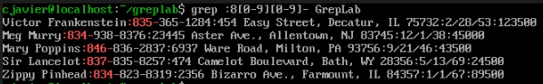
Command used: grep :8[0-9][0-9]- GrepLab
Explanation: Understanding the format of the line can provide easier filters to use grep with. Because the phone numbers come directly after a colon and right before a dash, they can easily be identified using those characters in the argument. While the argumen will begin with :8, the two “wildcard” digits after will need to be provided a range, which can be done so using brackets. [0-9] will signify any digit from 0 to 9. Ending it with a dash will prevent cross-matching with the zip code at the end, which also begins with a colon.

- Print all lines containing an uppercase letter, followed by 4 lowercase letters, a space and one uppercase letter.
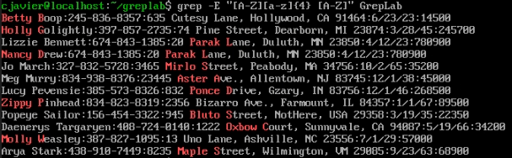
Command used: grep -E “[A-Z][a-z]{4} [A-Z]” GrepLab
Explanation: Now that spaces are involved, it is best practice to use quotation marks to better indicate to the system what is included in the main argument and what is not. The -E option allows for the use of extended regex arguments, which can help further optimize the filter. Similarly to above, if there is a wildcard letter, we will use brackets to signify that it can be any letter from a through z. This is also caps sensitive, so they must be differentiated. With extended regex, curly brackets can be used to indicate the repetition of a character (Linuxize).

- Print lines where the address begins with a two or three digit number (so this would be 12 main st or 123 main street but not 1234 main street).
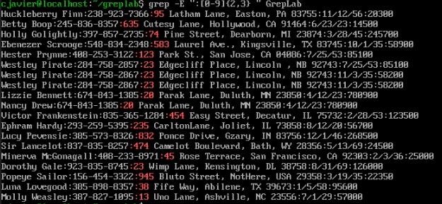
Command used: grep -E “:[0-9]{2,3} “ GrepLab
Explanation: Again referring to the format of the line, street addresses are delineated by colons and contain spaces after their numbers to begin the address name. After enabling extended regex, a comma is used to determine whether the repetition will be two or three numbers, which aligns with the filter request.

- Print lines where the person lives in Mass or Illinois
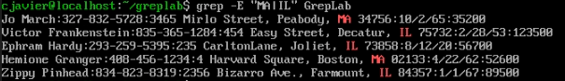
Command used: grep -E “MA|IL” GrepLab
Explanation: In extended regex, the pipe (“|”) operator signifies or logic in the argument. Using quotations so as not to trigger the pipe operator in the linux system (which is something different) the command returns lines that contain either one of the strings provided in the argument, representing Massachusettes or Illinois.

- Print lines containing the addresses that aren’t on a street (You might see St as shorthand for street)
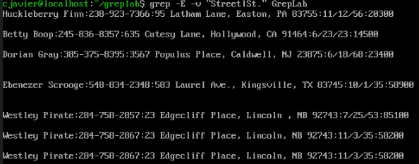
Command used: grep -E -v “Street|St.” GrepLab
Explanation: This time, two options are used to both enable extended regex and perform an inverse search. Observing the file, there are both “Street” and “St.” abbreviations, so those must be accounted for by again incorporating the pipe symbol’s or logic. This will exclude any line containing “Street” or “St.”, as they appear in the file.

Works Cited
- Regular expressions in GREP (regex) | Linuxize. (n.d.). https://linuxize.com/post/regular-expressions-in-grep/
- Sentika, A. (2025, April 28). How to use the GREP command in linux + examples . Hostinger Tutorials. https://www.hostinger.com/uk/tutorials/grep-command-in-linux?utm_medium=ppc&utm_campaign=PMax-WordPress%7CNT%3ASe%7CLO%3AUSA&gad_source=1&gad_campaignid=23059430811&gbraid=0AAAAADMy-hZ8p3s7kniOkvdxQK8bkd3PR&gclid=CjwKCAjwmNLHBhA4EiwA3ts3mdoCTIxnBh1MilLLN2PrIo2kuTV6Fzql8kqInjEL8vN2ATIyKh9UuhoC_kEQAvD_BwE

